Neighbourhood Plan Working Party Meeting, by Zoom
7.30pm on Monday 22nd March 2021
Minutes
Those in attendance: R. Hughes, M. Inskip, S. Partington, L. Dupre, S. Smith, I. Poole, A. Scott
Apologies: None
- Proposed Timeline:
Ian Poole has created the following timeline with a couple of options depending whether an additional site for housing needs to be identified;
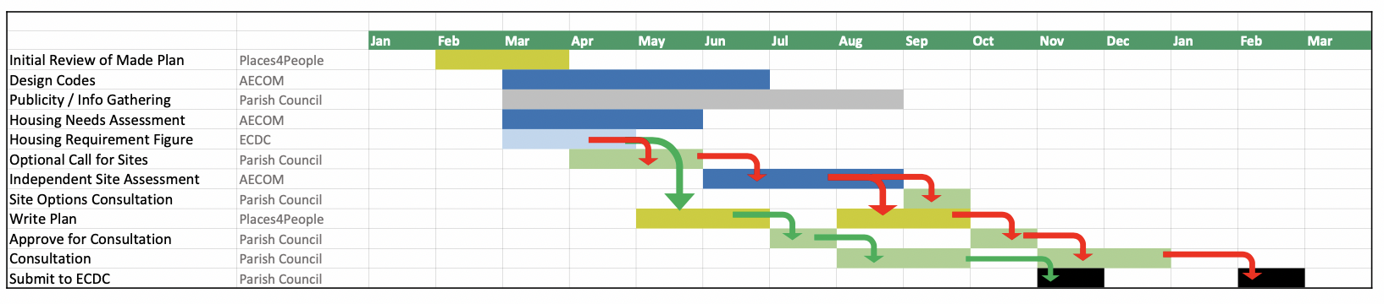

Ian has asked ECDC for an updated housing figure for the parish. If this doesn’t change from the one used for the original Neighbourhood Plan, it will be possible to go straight into re-writing the plan. If it has increased, such that an additional site has to be allocated, then it will be necessary to make a call for sites and to have those sites assessed and consultation adding 3 to 4 months.
Alex joined the meeting with the aim of contributing his experience on ecology. Ian will look to sharing the Reach NP Ecological Appraisal when it is available.

- Preparation for Neighbourhood Plan Review:
Mepal Parish Council has confirmed that they would like any part of Mepal to be excluded from a revised Sutton Neighbourhood Plan. It was agreed that we should proceed with the review of the Neighbourhood Plan on the current Sutton Parish Council boundaries.
Action: Ian to discuss proceed for agreeing the revised boundaries for the Neighbourhood Plan with East Cambs District Council
Recommendation to Full Council: To confirm that the boundaries for the revised Neighbourhood Plan should be the current Sutton Parish boundaries.

- Initial Review of existing Sutton Neighbourhood Plan:
The working party reviewed Ian’s “Sutton NP Initial Review March 2021” document and agree to all recommendations for review with the following comments;
- Need to consider re-visiting the Key Issues in Chapter 4 of the Neighbourhood Plan because of changes such as the opening of the Co-Op and the impact of COVID-19. This would need some form of public consulation.
- Need to revisit Local Green Spaces to see if there are additional areas to allocate.
- Need to review Policy NP2 in the light of the ECDC Natural Environment SPD and the desire for a more extensive review of biodiversity in the parish. Alex will be able to provide expert input into this review. We could also consider involving the Conservation Society in some aspects. There was some discussion of the remaining part of Watergull Orchard.
Action: Stan to aim confirm owner of the former Watergull Orchard
- Chapter 9 needs updating, in particular to take note of the opening of the Co-op.
- Chapter 11 Traffic & Transport should be review. This could be done owned by the Traffic & Transport working party.
- Chapter 12 Sport, Recreation and Leisure could be owned by the Sports & Recreation working party.

- Housing Needs Survey and Design Code:
We have now engaged Aecom to create a Housing Needs Survey and to create a Design Code in preparation for the review of the Sutton Neighbourhood Plan. They recently met with the Clerk and some of the working party members.

Date of Next Meeting: Monday 26 April at 7.30pm by Zoom

